

**YEAR: 8**

**SEMESTER 2, 2018**

**SUBJECT: Science**

**Test: Body Systems**

**TIME: 60 minutes**

**QUESTIONS: 10 Multiple Choice (10 marks)**

**9 Short Answer (41 marks)**

**1 Extended response (4 marks)**

**TOTAL MARKS: 55 marks**

**DO NOT WRITE ON OR MARK THIS PAPER**

Multiple choice **(10 marks)**

1. Which of the following is listed from simplest structure to the most complex structure?
2. Cell, tissue, organ, system.
3. Tissue, system, cell, organ.
4. Cell, organ, tissue, system.
5. Tissue, cell, system, organ.
6. Which type of blood vessels carry blood away from the heart?
7. Veins.
8. Arteries.
9. Capillaries.
10. Both arteries and veins.
11. A person with haemophilia where they blood is unable to clot. This would involve problems with which of the following blood component?
12. Plasma.
13. Platelets.
14. Red blood cells.
15. White blood cells.
16. Which of the following are the smallest blood vessels?
17. Capillaries.
18. Arteries.
19. Arterioles.
20. Veins.
21. The lungs, nose, and trachea are a part of which system?
22. Digestive.
23. Respiratory.
24. Reproductive.
25. Circulatory.
26. Which organ contains air-carrying tubes and tiny sacs?
27. Diaphragm.
28. Lungs.
29. Trachea.
30. Bronchi.
31. When in the lungs, _________________ the blood
32. oxygen enters.
33. oxygen leaves.
34. carbon dioxide enters.
35. carbon dioxide leaves.
36. Sexual reproduction is best described as
37. Reproduction with two or more parents.
38. Reproduction with no parents.
39. Pollination.
40. Reproduction with a single parent.
41. The offspring from an organism that reproduces asexually are
42. Different to their parents.
43. A combination of both parents.
44. Identical to siblings.
45. A different species.
46. An advantage of sexual reproduction is it
47. Occurs over a short period of time.
48. Causes genetic diversity.
49. Easy to find mates.
50. Has a low chance of survival.



**YEAR: 8**

**SEMESTER 2, 2018**

**SUBJECT: Science**

**NAME:**

**FORM:** **DATE:**

**Test: Body Systems**

**TIME: 60 minutes**

Multiple choice Short Answer Extended Answer Total

**/4**

**/41**

**/10**

**%**

**/55**

**SECTION ONE:** Multiple choice answers

Cross (X) through the correct answer.

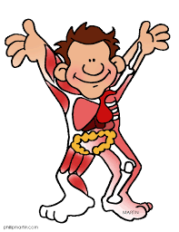

|  |  |  |  |  |
| --- | --- | --- | --- | --- |
| **1** | a | b | c | d |
| **2** | a | b | c | d |
| **3** | a | b | c | d |
| **4** | a | b | c | d |
| **5** | a | b | c | d |
| **6** | a | b | c | d |
| **7** | a | b | c | d |
| **8** | a | b | c | d |
| **9** | a | b | c | d |
| **10** | a | b | c | d |

Short Answer **(41 marks)**

1. **Name and describe** the function of each of the components of blood. (4 marks)

1. Below is a simple diagram showing the structures of a mammalian heart.

On this diagram you must

* 1. **Label** the blood vessels entering and leaving the heart (2 marks)
  2. **Label** the chambers of the heart (2 marks)
  3. **Use arrows** to show the direction of blood flow (2 marks)

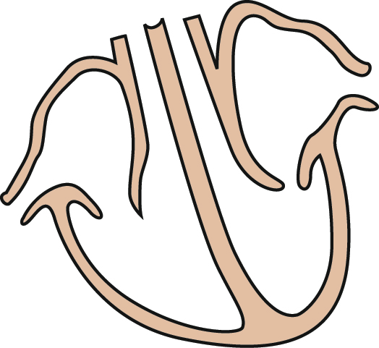

1. **Name and describe** the function of and differences between the types of blood vessels.

(6 marks)

1. 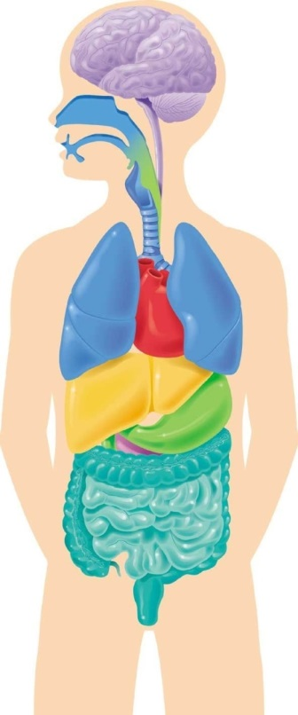**Circle and label** at least **four** of the organs which are involved in **breathing**. (2 marks)
2. a. What is the function of alveoli? (1 mark)

b. How are the alveoli efficient for their function? (2 marks)

1. a) Label the two circles of the Venn diagram below indicating the **two main types of reproduction**.

(2 marks)

b) In the middle or overlapping section, list the **two** **similarities** between the two types of reproduction. (2 marks)

c) In the left and right sides, list the **differences** between the two types of reproduction. (4 marks)

1. 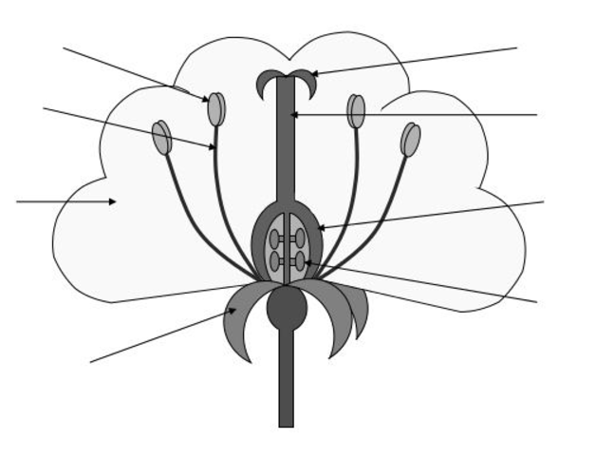Correctly label **at least six** arrows on the diagram of the dissected flower below to identify both the male and female reproductive parts. (4 marks)
2. List **two** types of asexual reproduction that you learnt during this module in the table below as well as how this type of reproduction works and an example of an organism that uses this type of reproduction (6 marks)

|  |  |  |
| --- | --- | --- |
| **Type of asexual reproduction** | **Describe how it works** | **Example of an organism that uses this type** |
| **Example**  **Binary Fission** | **Example**  **An organism that is able to split itself in to two to create a new organism.** | **Example**  **Bacteria** |
|  |  |  |
|  |  |  |

During this module you prepared a PowerPoint presentation comparing a body system of a mammal to a different organisms.

1. Provide a short summary of what you know about the similarities or differences of body systems in different organisms. (2 marks)

Extended Answer 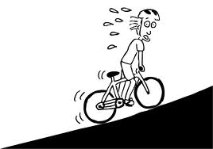On one particular morning Simon decides to take a short cut to school. The short cut that he takes involves a particularly high hill. At the top of the hill he notices that his breathing and heart rate are both much higher than they would be if he was riding on flat road.

1. Explain, using your best scientific knowledge, why **both** the breathing rate and heart rate increases during hard exercise. (4 marks)

**END OF TEST**

**Please check your work!**